SMART ALCOHOL INTOXICATION DETECTION AND PREVENTION SYSTEM USING AI
Scope and Limitations
Department of Computer Science and Engineering, TKR College of Engineering and Technology (Autonomous)
Batch A6 (CSE-A) · Academic year [ACADEMIC YEAR]
Table 1: Project team
S.No. | Student name | Roll number
1 | B PRANITHA | 23K91A0522
2 | BANTU KAVYA | 23K91A0531
3 | DASARI VIVEKA SARVESHWARI | 23K91A0560
4 | BEKKAM VAMSHI | 23K91A0534

Project guide: N. PADMAVATHI
Chapter and section numbers quoted in the text (for example Section 6.6 or Chapter 8) refer to the full project report, 17.Final Document. Figures and tables in this document are numbered from 1.

1. SCOPE

1.1 In scope
Table 2: In scope
# | Item
1 | A Windows laptop prototype that watches one person's face through a webcam and estimates possible drowsiness or impairment from visible eye and head cues (eye aspect ratio, closure time, closed-eye fraction, blink rate and image-plane head roll).
2 | Transparent, explainable rules with three outputs - Normal, Possible impairment or drowsiness, Unable to assess - and a stated reason for each verdict.
3 | Quality gating: no verdict when lighting, sharpness, motion, face count, eye size or eye geometry is unreliable.
4 | Personal calibration of the closed-eye threshold from 8-15 s of the rider's own open eyes, and six validated, editable thresholds.
5 | On-screen warning and an optional bell with a cooldown; four scripted simulation scenarios for demonstrations without a camera.
6 | Numeric event history in SQLite with CSV export; no video or face image is ever stored.
7 | Two front ends over the same Python modules: the original Tkinter desktop application and a FastAPI + React web application with a demo login.
8 | An offline, subject-disjoint evaluation pipeline for a consented, labelled measurement CSV (never used by the live rules).
9 | Measurements of the eye-state component on public data, of the rule engine on scripted streams and of speed, plus 20 unit tests and a 34-check API smoke test.

1.2 Out of scope
Table 3: Out of scope
# | Item
1 | Alcohol detection. A camera cannot confirm alcohol consumption; the system never reports alcohol.
2 | A trained deep-learning sober-versus-intoxicated classifier (no intoxication dataset was available).
3 | Gaze deviation, saccades, nystagmus, facial expression, voice or any non-visual signal.
4 | A prevention action: ignition lock, vehicle immobilisation or notification of a registered contact. The system never controls ignition, brakes or vehicle power.
5 | In-vehicle or on-motorcycle deployment, helmet and visor handling, vibration, night riding or an embedded device.
6 | Medical, legal or road-safety certification; use by the public; any claim of fitness to ride (Normal does not mean fit to ride).
7 | Multi-user accounts, a production identity system, cloud hosting or mobile applications.
8 | Full 3D head pose; only image-plane roll is computed.

The boundary is deliberate. The batch title speaks of alcohol intoxication detection and prevention; what could honestly be built and measured in the available time is a drowsiness-type impairment indicator with explainable rules. Everything that would turn it into an alcohol test or a road-safety device - labelled intoxication data, a trained classifier, vehicle integration, validation on riders and regulatory approval - lies outside the project and is listed as future work.
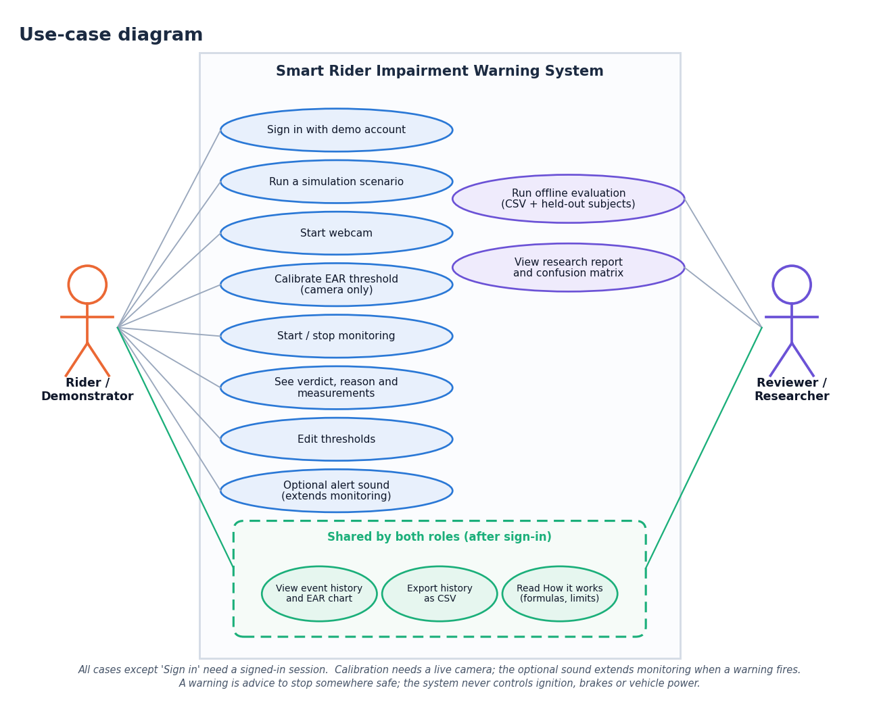
Figure 1: What the user can do within the scope of the system (use-case diagram)

2. ASSUMPTIONS
• The rider's face and both eyes are visible to the camera, with diffuse front lighting and no dark or reflective eyewear.
• One person is in front of the camera; the laptop is secured and the demonstration is stationary.
• Calibration is done while the rider is naturally alert with eyes open; the system cannot certify that the rider was alert.
• A webcam delivers roughly 15 to 30 frames per second at 640 x 480 pixels, and the browser (Chrome or Edge on localhost) allows camera access.
• The default thresholds are engineering choices for demonstration, not measured safety specifications.
• The Google Face Landmarker model is downloaded once and run locally; no internet access is needed during use.
• Anyone who loads research data holds the participants' consent; a consent=yes column cannot verify it.

3. LIMITATIONS
• Not an alcohol detector. Closed eyes, low EAR and head tilt have many causes (sleep loss, medication, illness, eye shape); open eyes do not establish alertness, and sober people can be flagged.
• No intoxication data. No labelled sober/intoxicated recordings exist in this project, so no accuracy for intoxication is claimed, and the deep-learning classifier requested in the objectives was not built.
• No prevention action. The system warns on screen and by bell only; it cannot stop a vehicle or notify a contact.
• Conservative default threshold. On public data the default EAR threshold of 0.21 labels about one open eye in seven as closed; calibration is the intended remedy but was not measured per person.
• Strict quality gates. Roughly 44 % of the 100-pixel test images pass; halving the image brightness already blocks assessment; a few sunglasses images passed the gates.
• Slow reaction. With the default rules a closure shorter than about 2.5 s never warns, and the closed-fraction rule needs 8-10 s of history.
• Single data source and machine. The eye-state measurement uses one public still-image dataset whose classes come from different sources; no helmet, visor, glasses-in-motion, vibration, night or demographic study was done; all timings come from one i5-12500 laptop without a GPU.
• Image-plane roll only. Head roll is tilt in the image, not yaw or pitch, and depends on camera placement.
• Prototype security. Demo credentials are displayed on the login page, CORS is open, and no penetration test was performed.
• Research pipeline untested on real data. The offline classifier has only been run on a generated synthetic file, which is flagged as such.
Evidence from the measurements. On 2,423 public face images the EAR separates closed from open eyes with an AUC of 0.989, but at the default threshold 179 of 1,231 open eyes are called closed (specificity 85.5%); only 44.1% of the images pass the shipped quality gates. These figures come from one dataset, one machine and one run per measurement and carry no confidence interval.
Table 4: Risks and mitigations
Risk | Mitigation in the project
Output mistaken for an alcohol test or a fitness-to-ride certificate | Wording Possible impairment or drowsiness; disclaimer on every screen and in the README; Normal is accompanied by "This does not certify safety"
False warning from a naturally narrow eye | Personal calibration; thresholds editable within bounds; persistence before any warning
A guess made on a bad image | Quality gates take precedence; Unable to assess clears the evidence and restarts warm-up
Over-reading a synthetic result | Synthetic report carries a Synthetic data banner; simulation events are labelled SIMULATION
Privacy of faces | Frames live in memory only; the database stores numbers; no telemetry or upload
Unauthorised access | HMAC-signed expiring token, 401 on protected routes; local demo account only, no real personal data should be loaded

4. WHAT WAS NOT MEASURED
The following were not measured and are therefore stated as gaps, not estimated:
• Any accuracy, sensitivity or false-alarm rate for alcohol intoxication, or for sober versus intoxicated classification.
• Any deep-learning model: none was trained.
• Performance with real riders, helmets, visors, glasses, vibration, night riding or different skin tones and ages.
• Gaze deviation and any prevention action (ignition lock or contact notification), which were not implemented.
• A real labelled, consented dataset through research.py: the pipeline has only been run on a generated synthetic file.
• Long-duration false-alarm rate on real people (the 300 x 180 s streams are generated).
• Whether calibration beats a fixed lower threshold, because the test images contain no repeated subjects.
• Audible loudness of the alert bell, accuracy of variable-frame-rate video extraction, load and concurrency of the API, and browsers other than Chromium.

